batch_size = 64 , epochs = 100, lag = 5

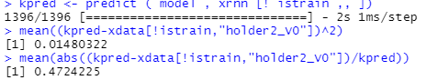

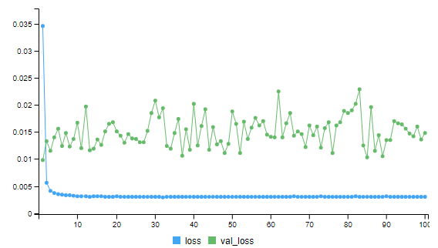

batch_size = 64 , epochs = 200, lag = 5

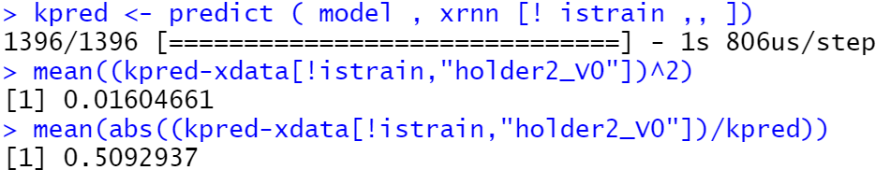

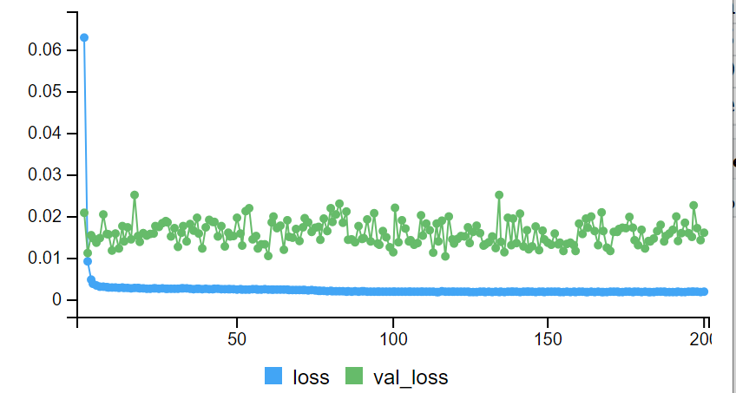

batch_size = 64 , epochs = 50, lag = 5

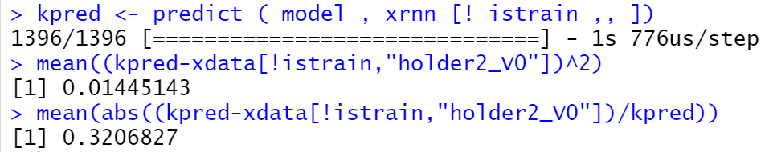

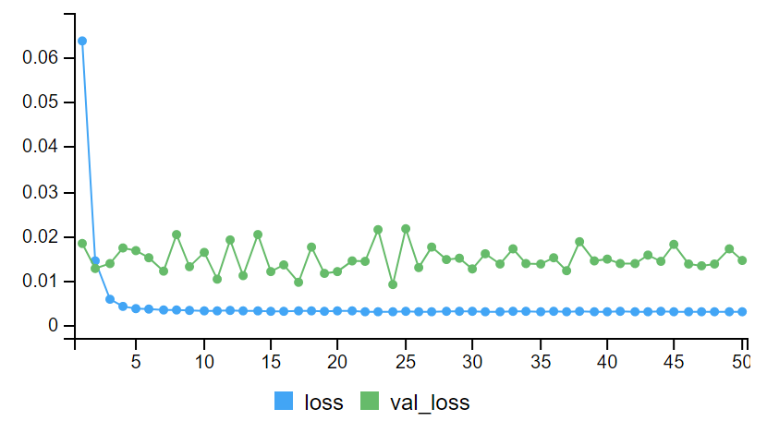

batch_size = 64 , epochs = 300, lag = 5

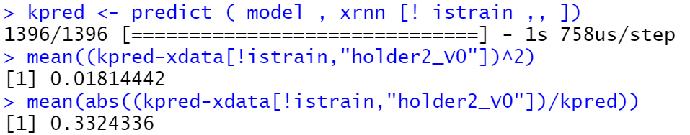

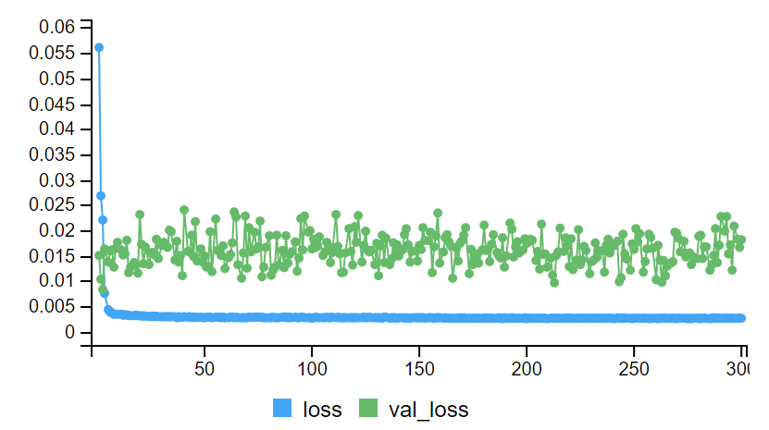

調整learning rate

batch_size = 4096 , epochs = 200, lag = 60, learning rate = 0.1

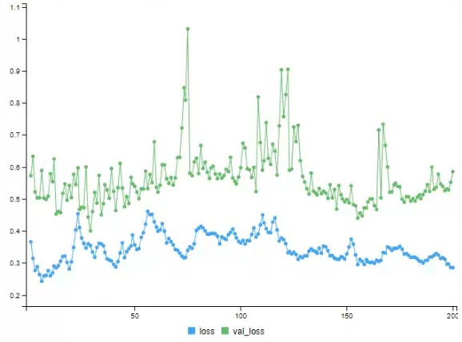

batch_size = 4096 , epochs = 200, lag = 60, learning rate = 0.01

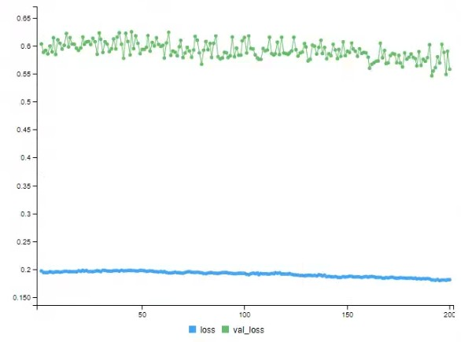

batch_size = 4096 , epochs = 200, lag = 60, learning rate = 0.001

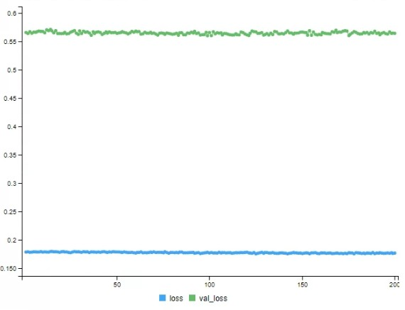

Lag = 10, tstar = 5

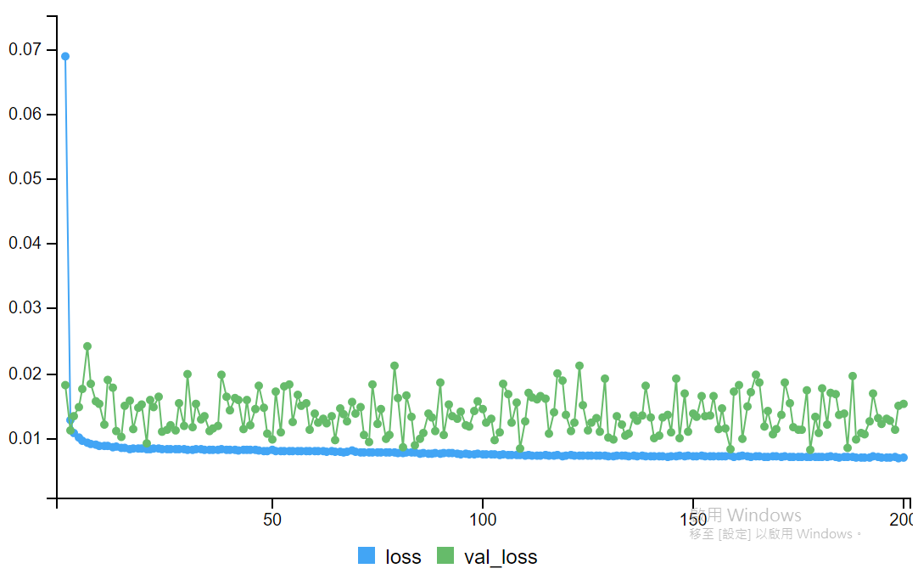

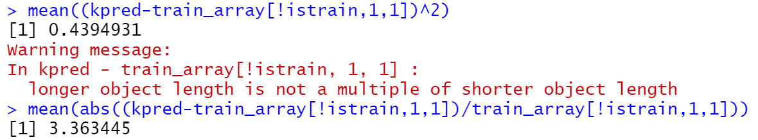

Lag = 30, tstar = 5

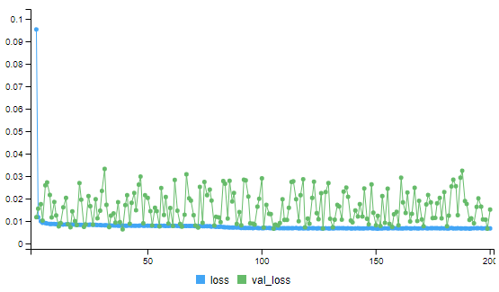

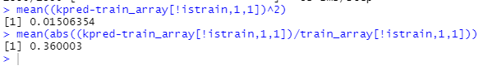

Lag = 60, tstar = 5

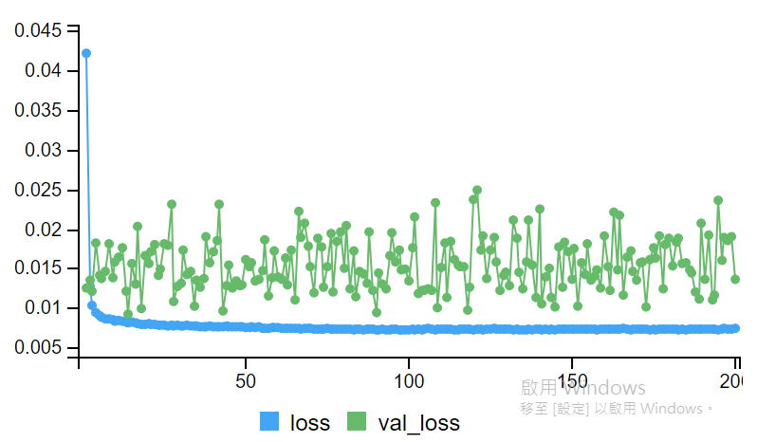

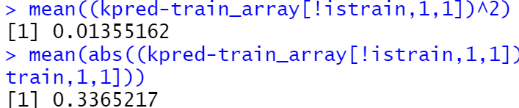

Lag = 10, tstar = 10

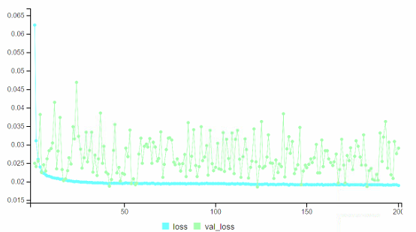



Lag = 10, tstar = 30

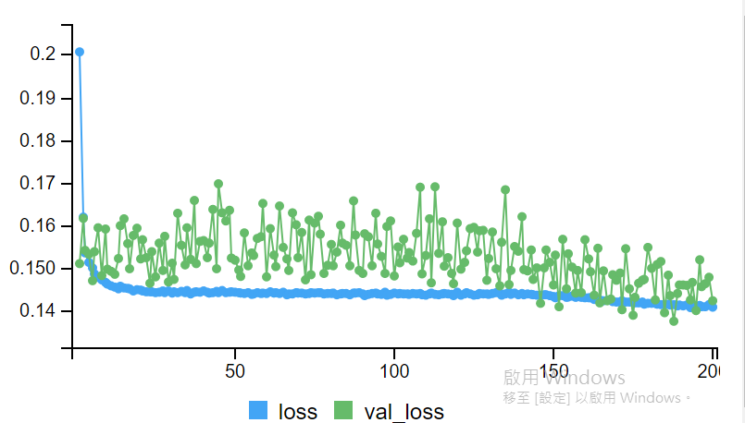

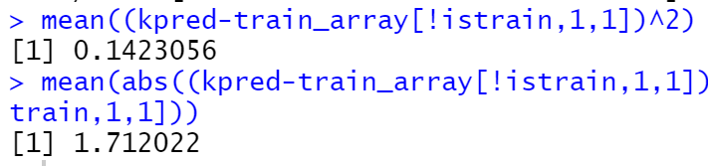

Lag = 30, tstar = 10

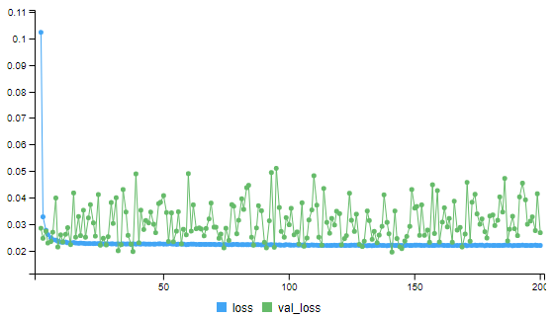

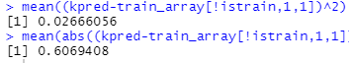

Lag = 30, tstar = 30

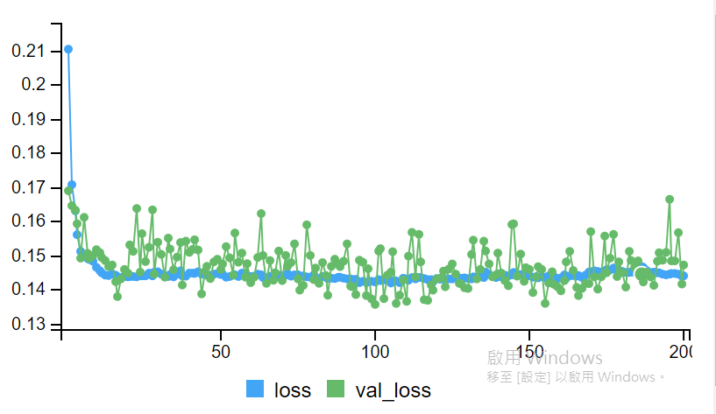

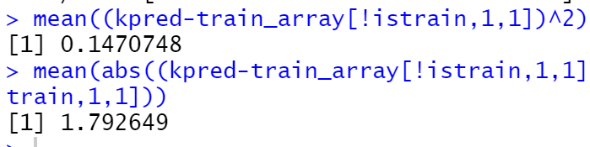

Lag = 60, tstar = 30

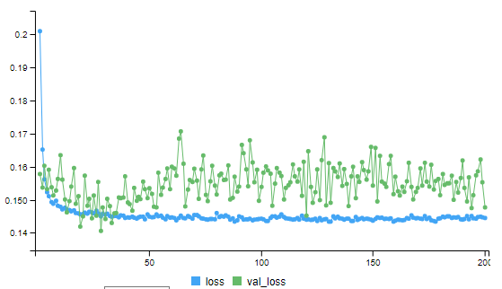



Lag = 60, tstar = 10

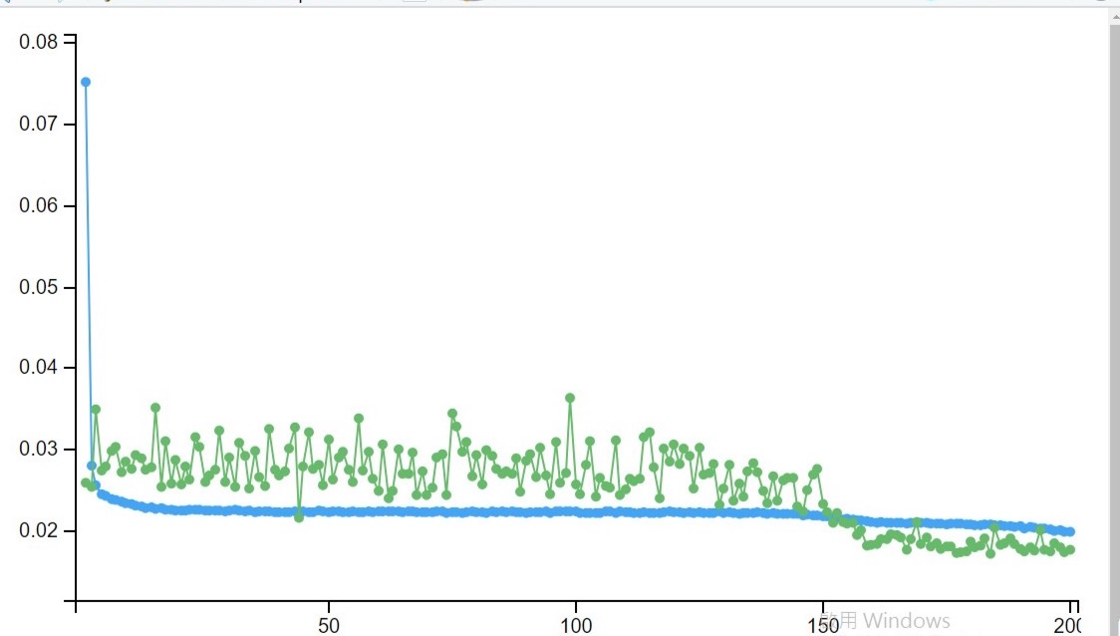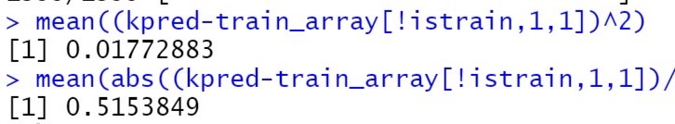

Lag = 30, tstar = 1

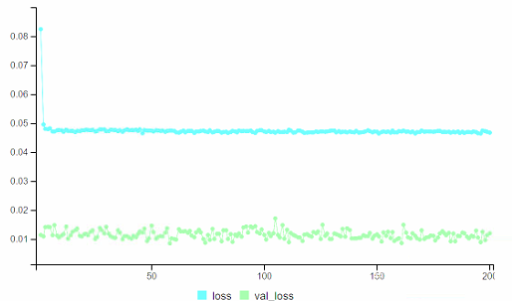



Lag = 10, tstar = 1

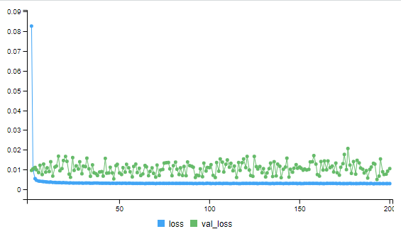

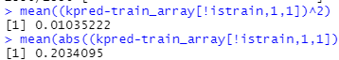

Lag = 10, tstar = 5

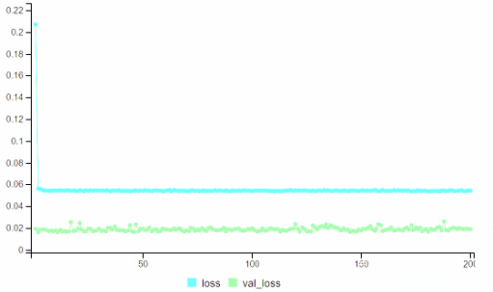



Lag = 60, tstar = 1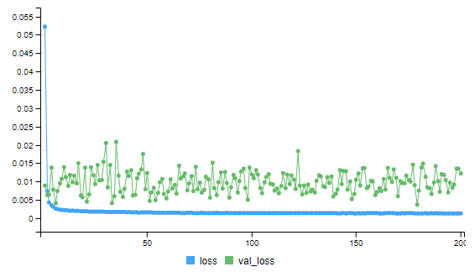

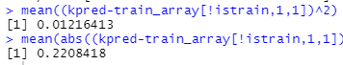

Lag = 10, tstar = 1

Learning rate = 0.0001

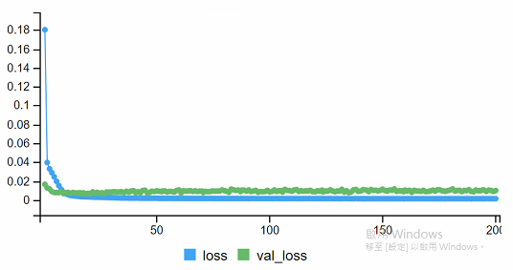

Lag = 60, tstar = 10

Learning rate = 0.0001

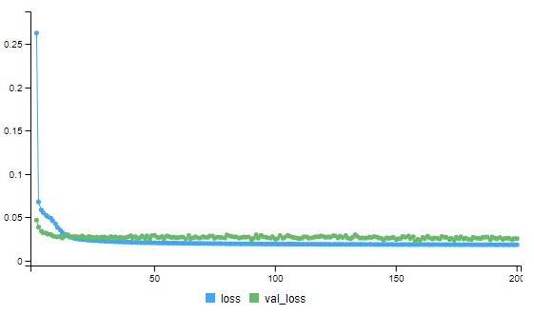



Training 只有11月

Lag = 30, tstar = 5

